Set up Simultaneous RingUnlike call forwarding where your work phone doesn’t ring, you can set your incoming calls to simultaneously ring your phone and another number or contact. This setting can help ensure that callers don’t get the busy signal and their calls don’t get missed. At the same time, they won’t be aware that their call was forwarded.

1. Click **Options > Call Forwarding.**
2. To set-up simultaneous ringing for your delegates or team-call group members, click the appropriate   
   option in the list.

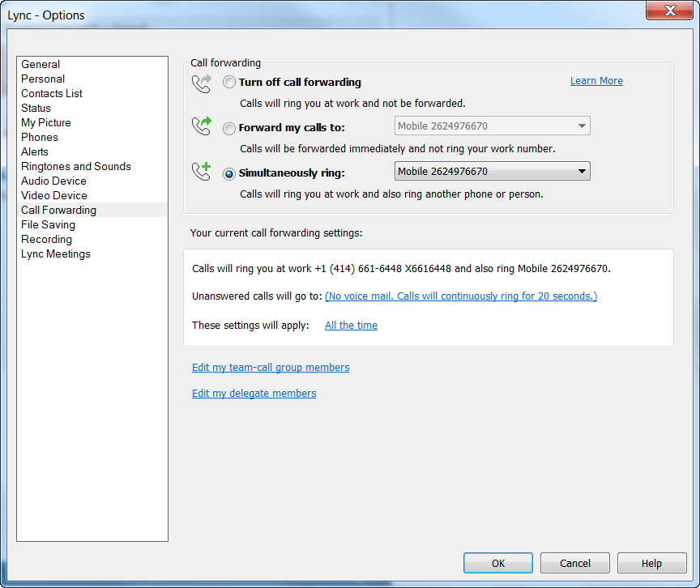

1. Select recipients by clicking **Add…**
2. Choose the number of seconds into the call ring that the Team Group or Delegate will hear the ring.
3. Once the selections are made, click **OK** to save them.

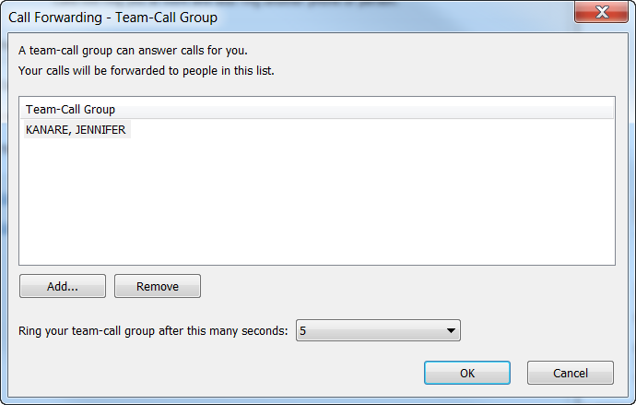

**Team-Call Group**  
Able to answer calls for you.  
  
**Delegate**  
Able to schedule Online Meetings on your behalf, and make or receive calls on your behalf. NOTE: A delegate must also be set up as your Delegate in Outlook.

Calls made on-behalf of a delegator appear as coming from the delegator.  
  
(File > Account Settings > Delegate Access)

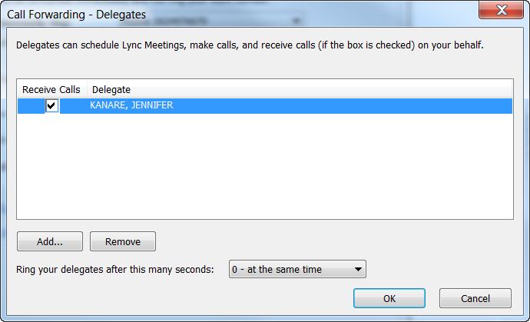

Set up Distinctive Ringtone for a Contact

Skype lets you set up a different ring for different types of calls. For example, if you have a team call group, you can pick a specific ringtone for that call group. To do this:

1. Click **Options > Ringtones and Sounds**.
2. In the **Calls to:** section, select the desired option. Next, pick the desired ringtone and click **OK**.

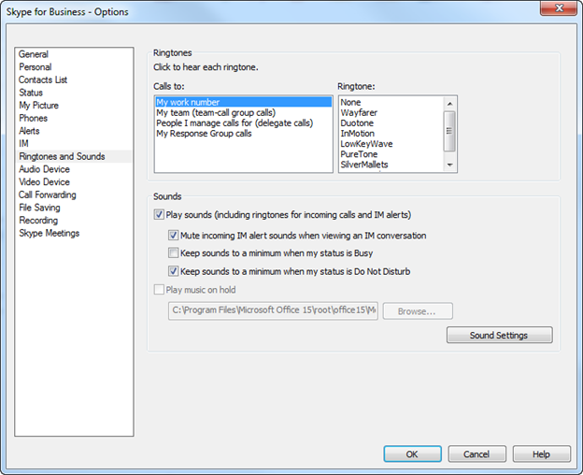

**Response Groups (MCR – Multiple Call Ring)**

Calls to the Response Group look like this:



Click the “toast-pop” to answer the call.

You can set a different ringtone to play when calls come into that Response Group.

To do this, go to:

**Skype > Options > Ringtones and Sounds**

Select the desired ringtone and **click OK.**

